**Manage Pet Type**

**‘Create New Pet’ Page** – This page is where you enter type of your new pet.

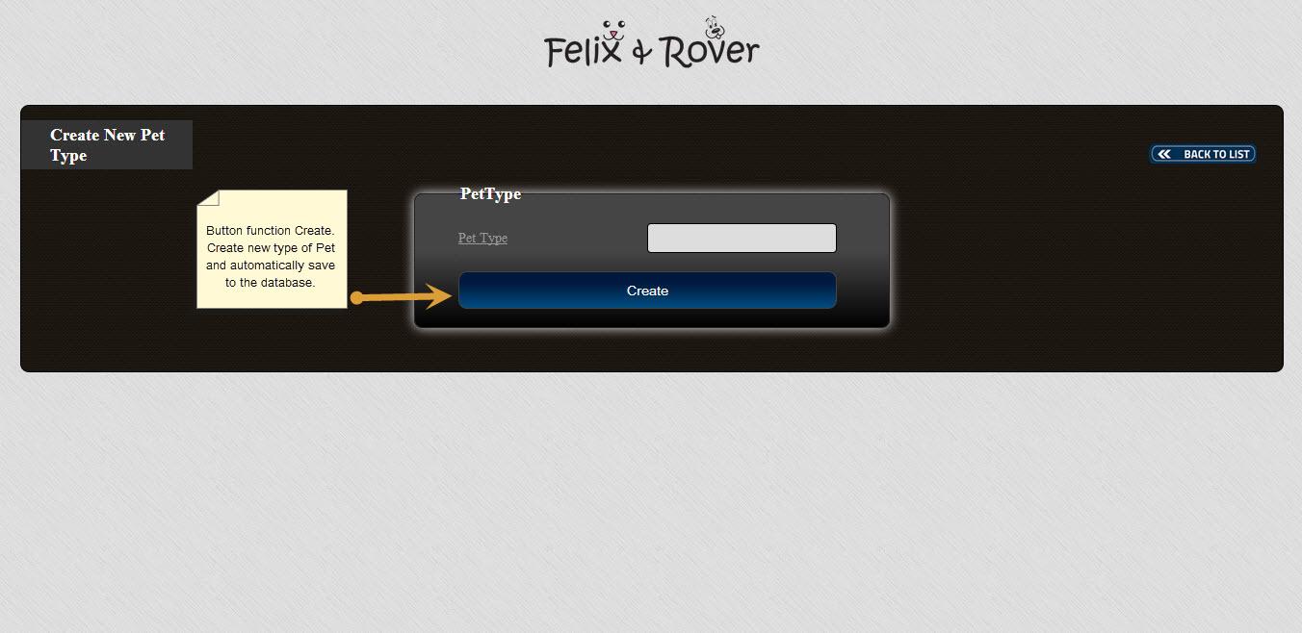

**‘Delete Pet Type’ Page-** This page is where you go to if you wish to delete type of pet.

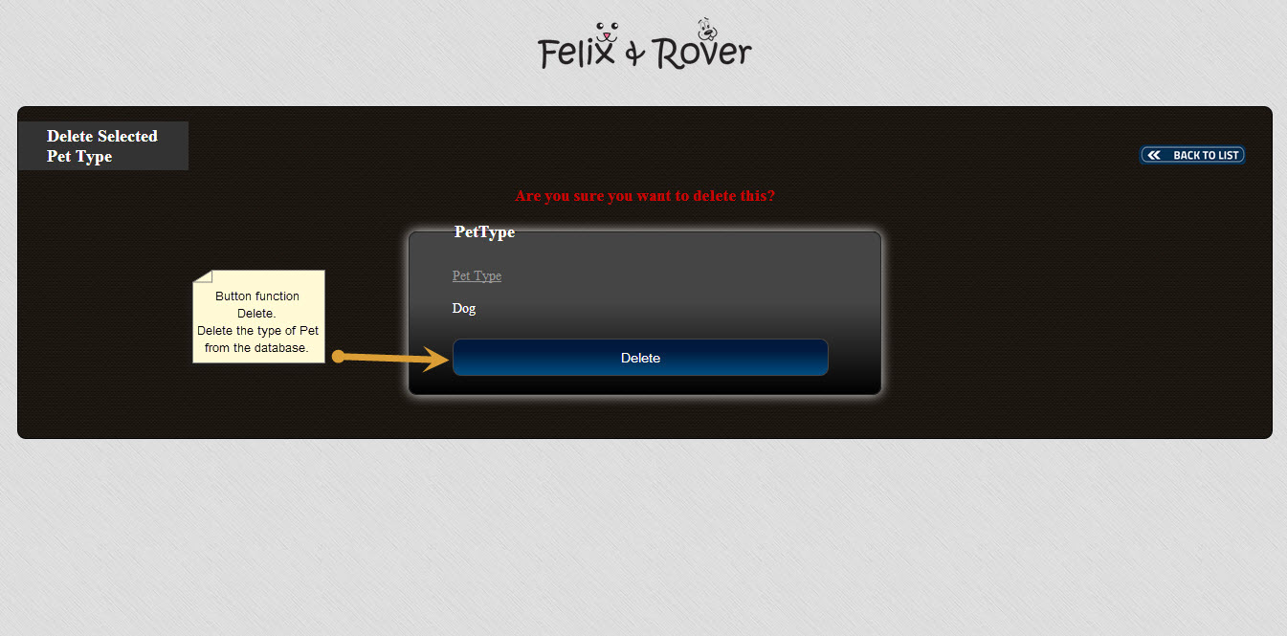

**‘List of Pet Types’ Page** – This page shows you a detailed list of registered type of pets. Here, you will see the pet type. You also have the option to edit or delete pet information, see pet details and enter new pet information.

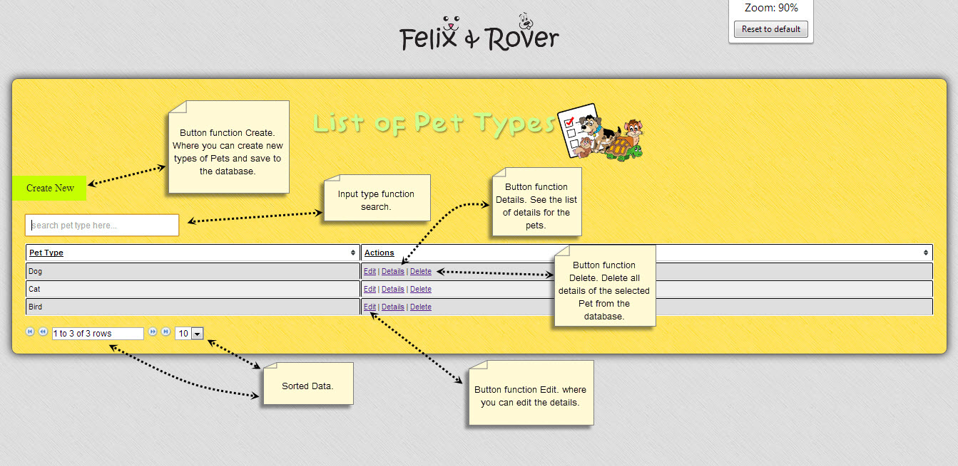

**‘Update Selected Pet Type’ Page** – This page is where you can update pet type details if you wish to make changes to its type.

